Michael Hall Allen, MD

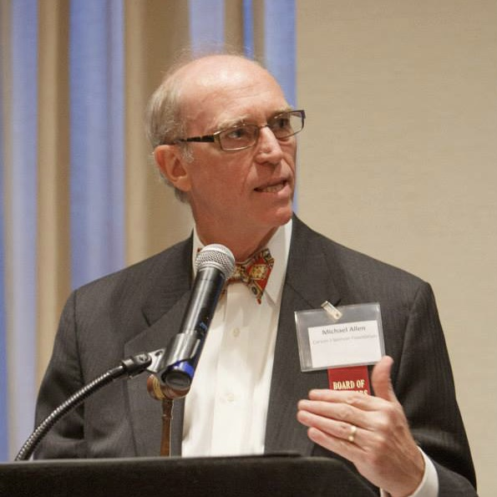
Dr. Allen hails from the Carolina Low Country and grew up on the Marine bases at Parris Island and Quantico. He attended Florida State University, received his medical degree from the Medical University of South Carolina and trained in psychiatry at the Institute of Living where he served as chief resident. He went on to serve on the faculty of Cornell and later New York University School of Medicine. While at NYU, he developed the model Comprehensive Psychiatric Emergency Program at Bellevue Hospital, mentioned in New York Magazine’s
“Best Hospitals in New York.” Currently, he is a professor in the Departments of Psychiatry and Emergency Medicine and a strategic advisor to the Brain and Behavior Innovation Center at the University of Colorado School of Medicine. He practices at the Johnson Depression Center, part of the National Network of Depression Centers. He is recognized as a national or international authority in several areas including suicide care, agitation, mood disorders and psychiatric emergency services. He is an author of US or world guidelines for the management of problems in these and several other areas.

In the field of suicide care, he has been a principal investigator for four large studies and a statewide implementation project with published data including 9891 suicidal individuals. These include (1) the NIMH Systematic Treatment Enhancement Program for Bipolar Disorder (STEP-BD), (2) the Psychiatric Emergency Research Collaboration, (3) the NIMH Emergency Department Safety Assessment and Follow-up Evaluation study (ED SAFE, the largest suicide intervention trial ever conducted) and (4) PRISM, a study of suicide screening in military primary care. As an outgrowth of the ED SAFE study and while medical director of Rocky Mountain Crisis Partners, he helped to develop the Hospital Follow Up Program for the state of Colorado which came to be viewed as the largest and best of its kind in the country serving 75 facilities around the state. He has recently served as principal investigator for a randomized controlled trial of a telephone application for suicide prevention. As a grantee of the Colorado Trust, he led the community organizing process that was the basis for legislation creating the Colorado Suicide Prevention Commision where he served as commissioner. He has contributed to several products on the Suicide Prevention Resource Center Repository. He currently serves as co-chair of the Zero Suicide Committee for the 15 hospitals of the UCHealth System and serves on the Steering Committee for the 988 National Suicide and Crisis Lifeline and the Scientific Advisory Board of the American Foundation for Suicide Prevention.

In the area of agitation, he received a NARSAD Independent Investigator award for the study of nicotine and agitation. He was a consultant and principal investigator from the inception of the inhaled loxapine program for agitation through FDA approval in the US and post-marketing studies in Europe. He was the lead expert for the Expert Consensus Guideline for the Management of Behavioral Emergencies and a contributor to international guidelines.

Dr. Allen is also viewed as an expert in mood disorders. He was a principal investigator for STEP-BD, the largest study of bipolar disorder ever conducted. He developed and validated the Clinical Global Impression Scale for Schizoaffective Disorder used in the paliperidone registration trials. He has been a principal investigator for pharmaceutical studies in many disease states and has led investigator training in 17 languages at more than 60 investigator meetings worldwide.

In the emergency psychiatry arena, he was a member the NIH Emergency Medicine Roundtable, served as president of the American Association and vice president of the International Association for Emergency Psychiatry, chair of the American Psychiatric Association Task Force on Psychiatric Emergency Services and as a member of an American College of Emergency Physicians clinical policy subcommittee.

He served as the inaugural chair of the Colorado Medicaid Pharmacy and Therapeutics Committee. He has also serverd as a consultant to the US Department of Justice Civil Rights Division, the Centers for Medicare and Medicaid Services, the Joint Commission, the Substance Abuse and Mental Health Services Administration and the National Institute of Mental Health.

Drr. Allen has been board certified in psychiatry and addictions. He is the author or editor of three books and a former editor of Emergency Psychiatry and General Hospital Psychiatry. He has over 100 original articles and his work has been consistently cited 250 times a year. He has been recognized by the UCHealth System with their Pioneer Clinical Innovation Award, by the Colorado Psychiatric Society with their Outstanding Achievement Award and by the American Psychiatric Association as a Distinguished Life Fellow.

